Executive Management Team

Mick Wolfe, Chief Operating Officer
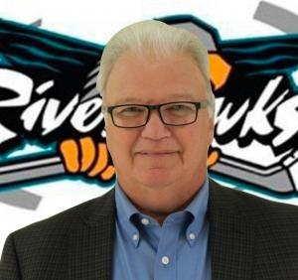
Director of Commercial Accounts, Meridian Credit Union
2009 Niagara Falls Chamber of Commerce Community Leadership Award
Chairman of the Niagara Falls Recreation Committee & Gale Centre Fundraising Task Force
Member of the Niagara Falls Sports Foundation, Niagara Falls Sports Wall of Fame Committee, the Bob Gale Recreation Fund and Niagara Falls

Contact:
mwolfe@riverhawks.ca

Fred Sacco, President & General Manager
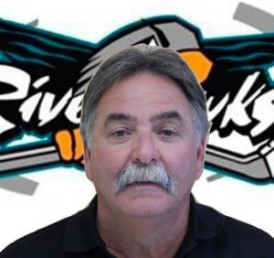
President, Sacco Construction & Kandu Pools

Contact:
fsacco@riverhawks.ca

Winston Auld, Assoc General Manager & Vice President of Hockey
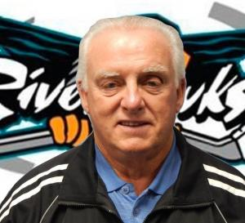
Convenor of PJHL South Bloomfield Division
With the RiverHawks [then Chippawa Merchants] since the inception in 1985
Original General Manager
OHA Crystal Puck Award recipient [2010]
Old Timers Hockey Hall of Fame member [Builder, Coach, Player, Manager - 1986]
Two time Doug Austin Sportsperson of the Year recipient [1988, 2013]
President of Play the Puck 55+ Hockey
Contact:
Winston.auld@cogeco.ca
905-354-0745

